**Managing Tables in Google Big Query with ‘BQ’**

**Overview:**

**This document provides instructions for creating and deleting tables in Google Big Query using the bq command-line tool.**

**Prerequisites:**

• Access to a Google Cloud Platform (GCP) project with permissions to create and delete Big Query datasets and tables.

• Google Cloud SDK installed on your local machine.

**Steps:**

1.Authenticate with Google Cloud: Execute this command to login to gcp account in Google SDK in local machine **“gcloud auth login”,** then you will see following pages once you executed this command.

Click on continue.

Click on Allow.

2.Install bq Command-Line Tool: This command installs the **bq** tool, which is used to interact with Big Query from the command line.

**Command: gcloud components install bq**

3.Verify bq Version: This command verifies that the bq tool is installed correctly and displays its version information.

**Command: bq version**



4.Create a Table: Create or obtain an SQL file (create_table.sql) containing the SQL schema for the table you want to create, Run the following command, replacing $file with the path to your SQL file:

**Command: bq query --use_legacy_sql=false --noreplace --nouse_legacy_sql < create_table.sql**

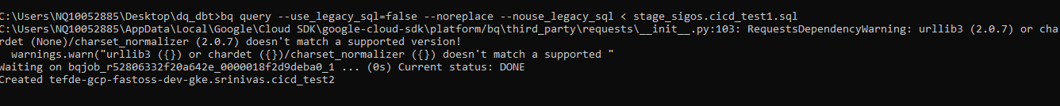

5.Delete a Table: Run the following command to delete the table

**Command: bq rm -f project_id:dataset.table_name**

